WAN Technologies

What Is a WAN?
A WAN means Wide Area Network. It is a big network that connects computers that are far away from each other, like in different cities or countries.
Simple idea: Think of a WAN like a long road that connects your house to a faraway friend's house, so you can send messages to each other.
There are many ways to build this long road. These ways are called WAN Technologies. The main ones we will learn are:
- Dial-up
- Leased Line
- ISDN (Integrated Services Digital Network)

1. Dial-up
Dial-up is one of the oldest ways to connect to the internet. It uses the normal telephone line that is also used for phone calls.
Simple idea: Dial-up is like using the same road for both your phone call and your internet message. Only one can use the road at a time.

Main Facts About Dial-up
- It uses POTS: This means Plain Old Telephone System, which is just the normal telephone line.
- It is low cost: You pay only when you use it, so it does not cost much.
- Speed: It can send data at 33.6 Kbps or 56 Kbps. Kbps means kilobits per second, which tells us how fast data moves. This is very slow compared to today's internet.
- At your home: A modem is connected to your telephone line. A modem changes computer signals into sounds that can travel on the phone line, and back again.
- At the provider's side: A box called RAS (Remote Access Server) answers the call. It checks who you are and connects you to the internet.

How Dial-up Works, Step by Step
- Hardware: A modem turns the computer's digital data into analog sound signals for the phone line, and turns it back when data arrives.
- Connection: The modem dials a phone number to call the internet company (ISP), using a normal phone cable called RJ-11.
- Data Transmission: Once connected, the computer and the ISP start sending data to each other.
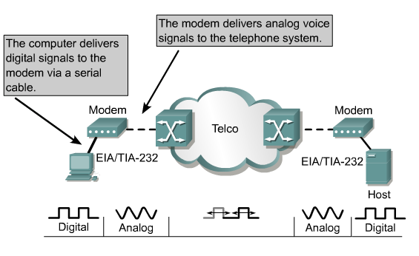
Figure 1: How a dial-up connection moves data between a computer and a host through the telephone system.

Why Dial-up Was Special
- Slow speed: It was much slower than today's internet.
- Shared line: While the internet was on, the telephone could not be used for calls.
- Funny sounds: Connecting made beeping and hissing noises, because the modems were talking to each other.
- Old technology: It was common in the 1990s, before faster internet came.

2. Leased Line
A leased line is a private telephone or data line that a company rents just for itself. Nobody else uses this line.
Simple idea: A leased line is like having your own private road, just for you, instead of sharing the road with everyone else.

Main Facts About Leased Line
- Purpose: It gives a direct, point-to-point connection between two places.
- Analog leased line: Can carry data up to 9.6 Kbps.
- Digital leased lines: Can carry much more data, such as 64 Kbps, 2 Mbps (called E1), 8 Mbps (called E2), or 34 Mbps (called E3).

Key Good Points of a Leased Line
- Dedicated bandwidth: The whole line belongs to one business only, so the speed is always there for them.
- Symmetrical speed: Sending data and receiving data happen at the same speed.
- Guaranteed uptime: A promise paper called SLA (Service Level Agreement) guarantees the line will work well.
- Low delay, high speed: Because it is a direct private link, data moves fast and smoothly.
- Private and secure: Only one business uses it, so it is safer from outside interference.
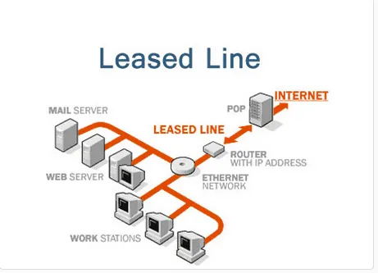
Figure 2: A leased line connects a company's servers and computers straight to the internet through one private path.
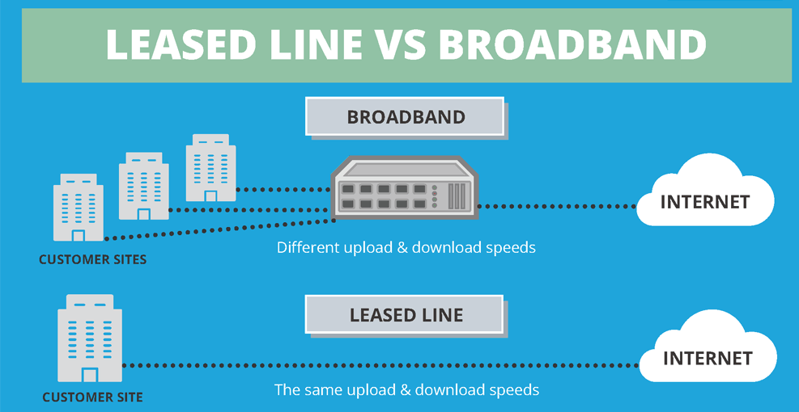
Figure 3: Leased line gives the same upload and download speed, while broadband often gives different speeds.

3. ISDN (Integrated Services Digital Network)
ISDN is another way to connect, instead of using normal analog phone lines. It sends data in digital form, which is faster and clearer.
Simple idea: ISDN is like sending a clear, neat typed letter instead of a messy handwritten one. The message travels faster and is easier to understand.

Main Facts About ISDN
- Speed: ISDN is faster than a normal telephone line connection.
- Switched digital network: It is made of many ISDN switches connected together.
- Address: Every point in the network has its own address, made of 15 digits.
- Access: Users connect to the ISDN network using standard ISDN interfaces.

Why ISDN Was Useful
- Digital transmission: It uses digital signals, so it can send more information clearly, even over long distances.
- Integrated services: Voice calls, fax, and data can all travel on the same digital line.
- Higher bandwidth: It is faster than old modems, reaching speeds up to 128 Kbps.
- Channel bonding: Two channels (each 64 Kbps) can be joined together for even more speed.
- Simultaneous services: You can use voice and data at the same time on the same line.
- Faster dial-up: ISDN gave a quicker and steadier dial-up connection than normal modems.
- Business use: Even after broadband became common, ISDN was still used by businesses, often as a backup line.
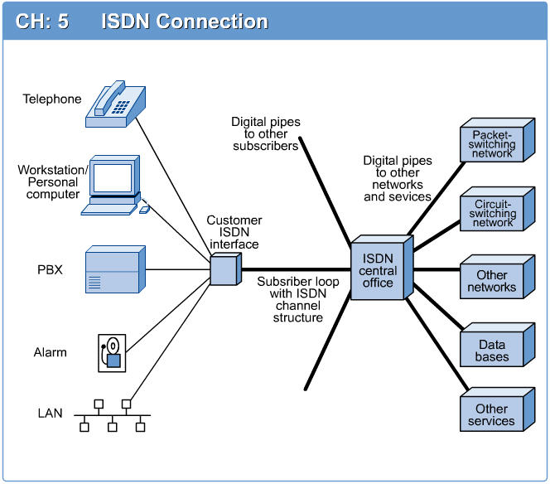
Figure 4: An ISDN connection links telephones, computers, and other devices to the wider network through the ISDN central office.

Two Types of ISDN Access
- Basic Access: Has two 64 Kbps data channels (called B channels) and one 16 Kbps signal channel (called D channel). Together they give 144 Kbps of service. The B channels carry voice and data, while the D channel carries signaling information.
- Primary Access: Has thirty 64 Kbps data channels (B channels) and one 64 Kbps signal channel (D channel), giving 2.048 Mbps of service in total. One 64 Kbps channel is also used for framing, which keeps the data organised.
Simple idea: Basic Access is like a small water pipe for a single home. Primary Access is like a big water pipe for a whole office building.

Quick Summary
- Dial-up: Cheap and slow, uses normal phone lines, was common in the 1990s.
- Leased Line: Private, dedicated, fast and reliable, but more costly.
- ISDN: Digital line that carries voice and data together, faster than dial-up, with Basic and Primary access types.

